

NAME
SUBJECT | SOCIAL STUDIES | CLASS |  | JSS 1 | DURATION |  | 2HOURS
SECTION A
OBJECTIVE [50 MARKS]

INSTRUCTION: ANSWER ALL QUESTIONS IN THIS SECTION

- 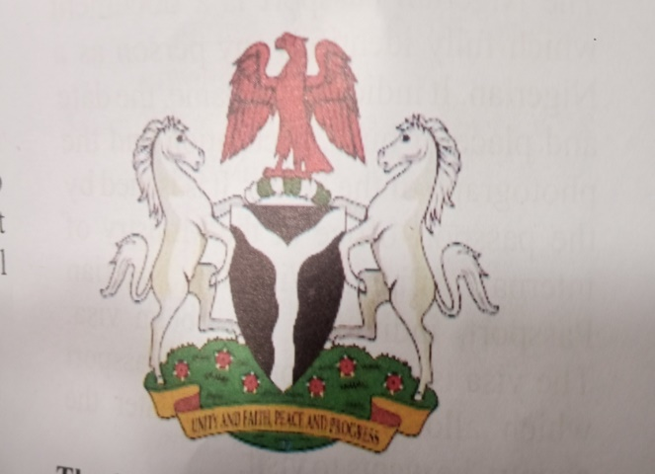

The diagram above is the __
- Nigerian National Symbols
- National International Passport
- Nugaria National Symbol
- Nupe National Symbol

- All these are situation that require negotiation except
- Number of children to have
- Whether to use contraceptives
- To have or not to have sexual intercourse
- The club to join

- HIV stands for
- Human Immuno Deficiency Vector
- Human Immuno Deficiency Virus
- Higher Immuno Deficiency Virus
- Higher Immuno Deficiency Vector

- All these are causes of HIV/AIDS except
- Unprotected sex
- Infected blood transfusion
- Eating with infected person
- Sharing of sharp objects

- All these are signs & symptoms of AIDS except
- Unexplained rapid weight loss
- Persistent & recurrent fever that last for more than one month
- Chronic or intermittent diarrhea
- None of the above

- Problems of HIV/AIDS include the following except
- It leads to broken home
- Loss of human resources
- Problems of discrimination
- None of the above

- How can we prevent HIV/AIDS ?
- Abstain from sex
- Use only screened blood
- Avoid sharing sharp objects
- All of the above

- The manipulation of examination process by the candidates , supervisor or invigilator is known as
- Electoral malpractices
- Examination malpractices
- Cultism
- Laziness

- The instrument below is used for ___
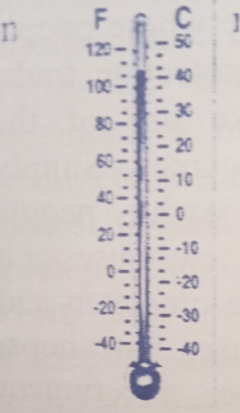
- Measuring wind
- Measuring direction
- Measuring temperature
- Measuring table

- All these are examples of examination malpractices except
- laziness
- inadequate prepration
- low self- esteem
- none of the above

- Which of these is not among the consequences of examination malpractices ?
- Dismissal from school
- Imprisonment of culprit
- It encourages laziness in student
- It reduces the cost of conducting examination

- All these are causes of cultism except
- Peer group influence
- Home background
- Exposure to foreign value
- None of the above

- The effect of cultism are
- Violence
- Breakdown of social values
- Criminal tendencies
- All of the above

- To curb the menace of cultism in our school , the following steps should be taken except
- There should be clear & bold billboard warning against cultism in our institutions
- School authority should be given full authority to dismiss any students or lecturer found to be cult member
- Parents/ guardians should teach their children moral values
- Powerful & influential people supporting cultism should be arrested

- Good negotiation cannot enhance relationship
- True
- False
- Not true
- Sometimes false

- People need negotiation when going on a date
- True
- False
- Sometimes true
- Occasionally false

- Negotiation exposes one to danger
- False
- True
- All of the above
- Sometimes false

- 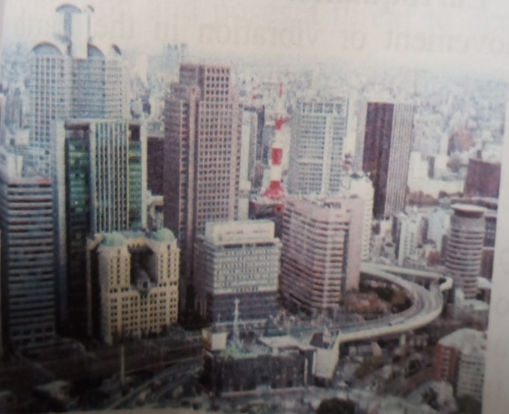
This is an example of ___
- Rural settlement
- Urban settlement
- Castle settlement
- Cloud settlement

- All these are skills require in negotiation except
- Good communication
- Listening
- Fighting
- Use of positive body language

- The diagram below is used to ___
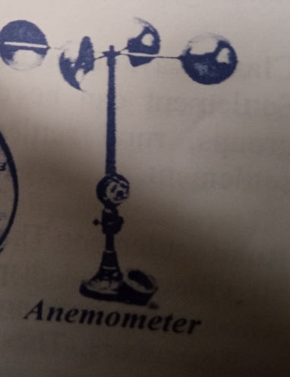
- Measure wind direction
- Measure wind speed
- Measure speed direction
- Measure temperature

- Which of these situation may not require Negotiation ?
- Types of parties to attend
- Types of food to eat
- Numbers of children to have
- None of the above

- All these are factors that enhances negotiation except
- Communication
- Discussion
- Tolerance
- None of the above

- Advantages of negotiation include all these except
- It promotes tolerance
- It promotes self- respect
- It enhances personal development
- It encourages child - abuse

- Which of these is not among the Nigeria National Symbols?
- The coat of arms
- The National Anthem
- The National Flag
- The Nigerian Army

- The white colour in the Nigeria National flag represent
- People
- Development
- purity
- agriculture

- The horse in the Nigeria Coat Of Arms represent
- National strength & pride
- National dignity
- National peace & love
- Unity & faith

- The National pledge emphasized the following except
- Insincerity
- Honesty
- Loyalty
- Faithfulness

- The silver in the Nigeria coat of arms represent two important river ___ & _____
- Congo & Zambesi
- Nile & Jordan
- Niger & Benue
- Ose & Osun

- Who composed Nigeria’s Old National Anthem?
- Miss Angela Gold
- Miss I.J William
- Miss F . Benda
- Mary Slessor

- Who wrote the new National Anthem?
- Prof . Akin Euba
- Emmanuel Odaise
- Taiwo Akinkunmi
- Mr Ugochukwu Daniel

- When did the new National Anthem replace the old ones ?
- 1st Oct 1978
- 1st Oct 1979
- 1st Oct 1980
- 1st Oct 1981

- How can individuals & groups promote National Unity ?
- Through discrimination
- Through tolerance
- Through Non-adherence to peace effort
- None of the above

- All these are institutions that can promote National unity except
- The federal character commission
- The unity school
- The National Youth Service Corps
- Constitution

- ……. Is made up of the natural & man –made features which can be seen & felt around us
- Physical environment
- Social environment
- Natural environment
- Mineral resources

- Physical environment can be divided into …..& …….. features
- Artificial & natural
- Physical & social
- Mineral & resources
- Present & past

- All these are man – made features except
- House
- Hills
- Towns
- Roads

- Which of these is not a natural feature ?
- Vegetation
- Road
- Valley
- Lowland

- Which of these factors does not influence the activities of man in an area ?
- Climate
- Relief
- Road
- Vegetation

- A piece of water surrounded by land is called
- Lake
- Valley
- Hill
- Island land

- 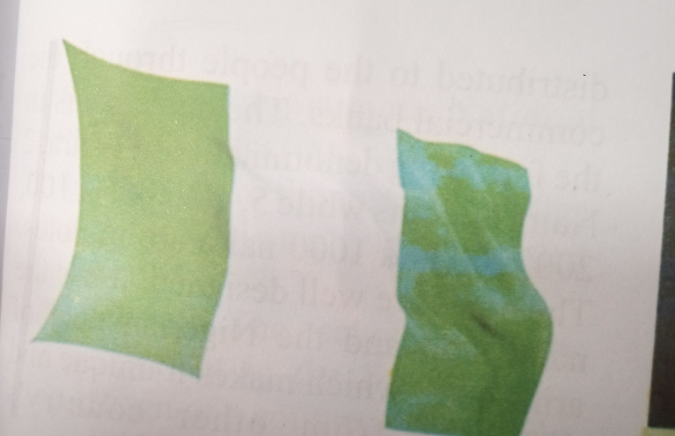
The diagram above represent the ___
- Confluence town
- Nigerian National Symbol
- Book symbols
- Night National Symbol

- A place where rivers enter the sea with many mouths is called …..
- Delta
- Estuary
- Island
- Valley

- …….. is a place where people settle for the purpose of safety , protection , trade or farming

- Village
- farm
- town
- settlement

- All these are a factors that determine the settlement pattern of an area except
- Closeness to the market
- Closeness to the people
- Availability of fertile soil for farming
- Closeness to power supply

- Settlement can be divided into two . These are
- Village & hamlet
- Rural & urban
- Town & city
- Homestead & village

- Which of these is not among the type of settlement ?
- Dispersed settlement
- Linear settlement
- Partially dispersed settlement
- Triangular settlement

- …… is the way in which the surface of the land is formed
- The relief of an area
- Natural resources
- Geography
- Settlement

- …….. are called the free gift of nature

- Settlement
- Relief
- Natural resources
- Physical environment

- Which of the following minerals is mined in Jos ?
A. Copper
B. Iron-ore
C. Gold
D. Coal

- Natural resources includes all of the following except
A. Building
B. Vegetation
C. Mineral
D. Oceans

- Coal is mined in …….
A. Jos
B. Enugu
C. Lokoja
D. Sokoto

SECTION B- THEORY
Answer only four questions from this part [40 marks]

1. (a) What is national unity ? [1mark]
(b) Mention four institutions that promote national unity [4 marks]
(c) Give five Nigerian national symbols [5 marks]

2 . (a) Define Cultism [1 mark]
(b) List 10 causes of cultism [5marks]
(c) State four consequences of cultism [4 marks]

3. (a) What is examination malpractices [2marks]
(b) Identify four ways of preventing examination malpractices [4marks]
(c)Mention four consequences of examination malpractices [4marks]

4. (a) Define Negotiation [1mark]
(b)Mention six factors that enhance negotiation [3marks]
(c)State four advantages of negotiation [4marks]
(d)Explain Negotiation techniques [2marks]

5. (a) What is the full meaning of HIV/AIDS [2marks]
(b). Mention four effects of STI [4marks]
( c.) State four ways of preventing HIV /AIDS [4marks]

